EX:8- Create a Virtual Hard Disk and allocate the storage using VM ware Workstation

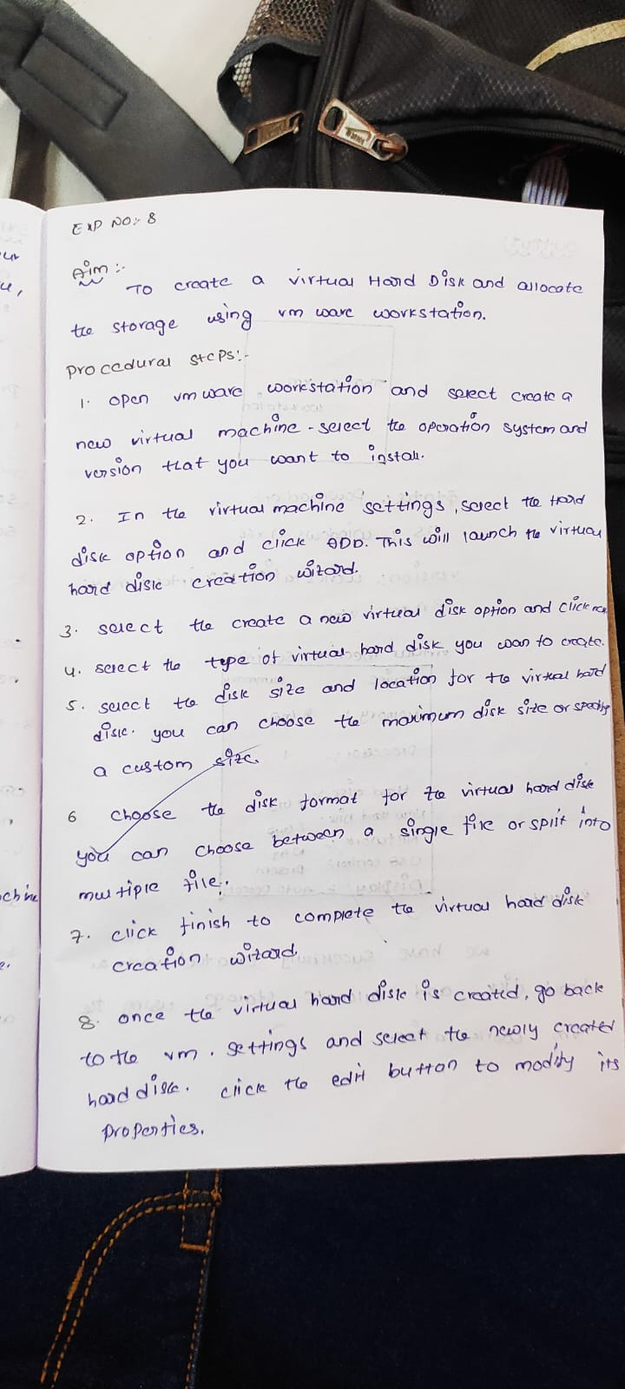

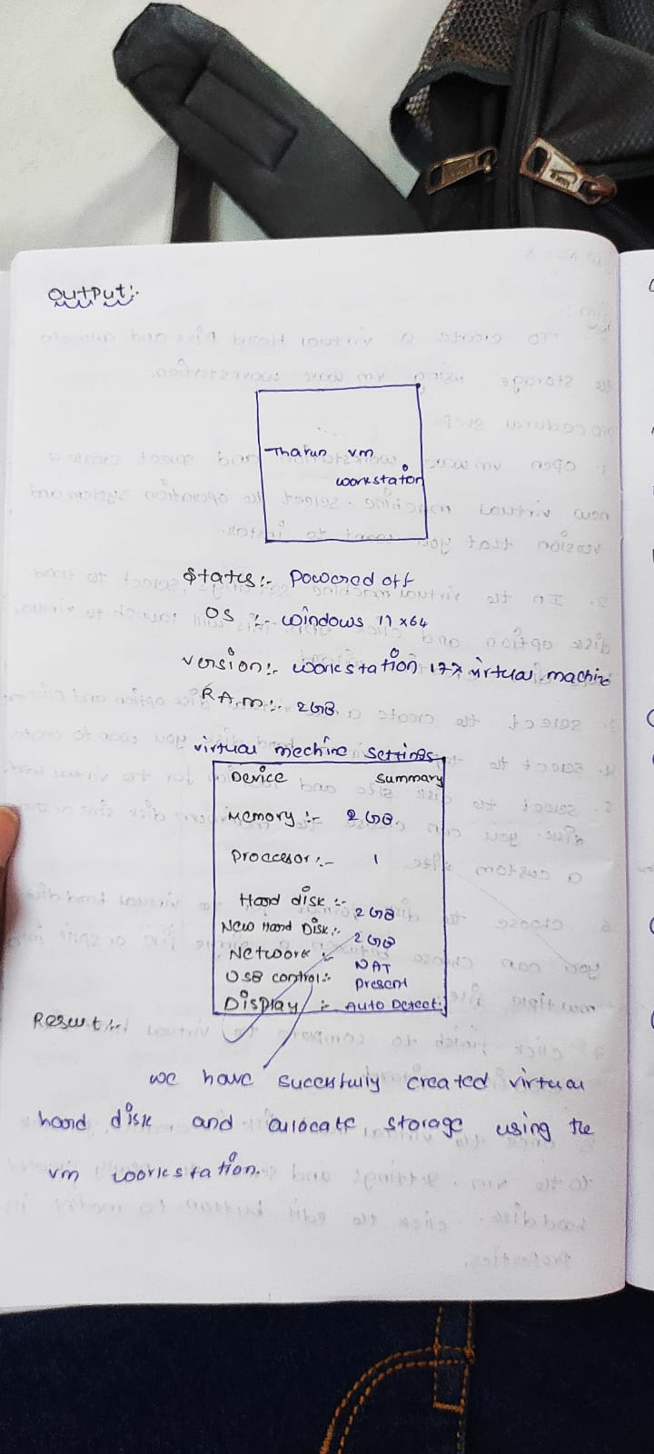

Enter the required hardwares and add the new hard disk 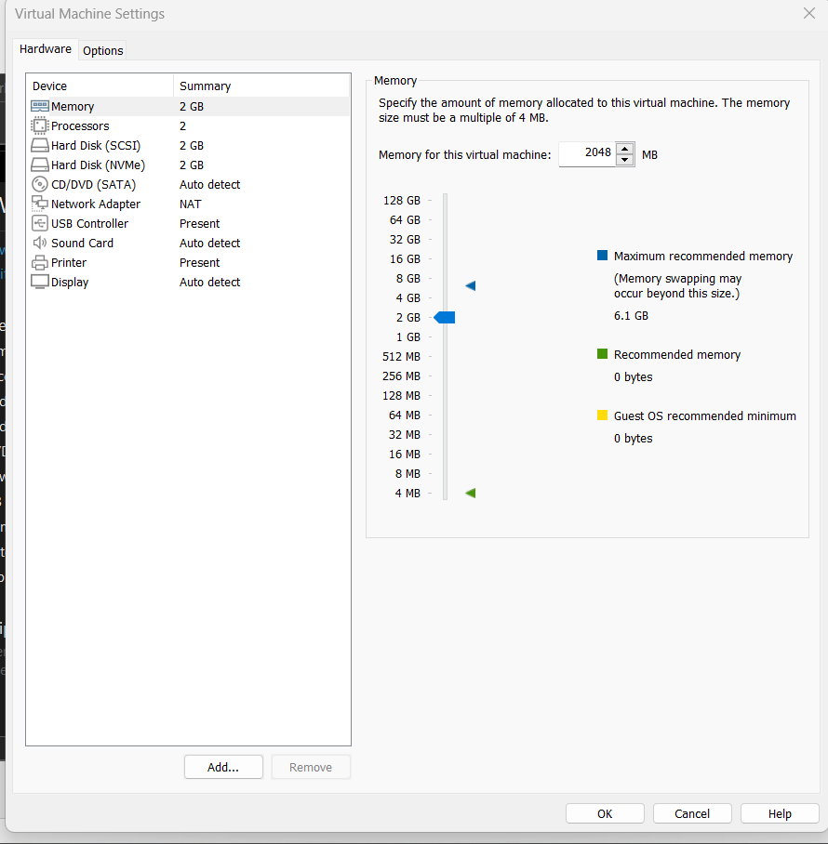

OUT PUT: